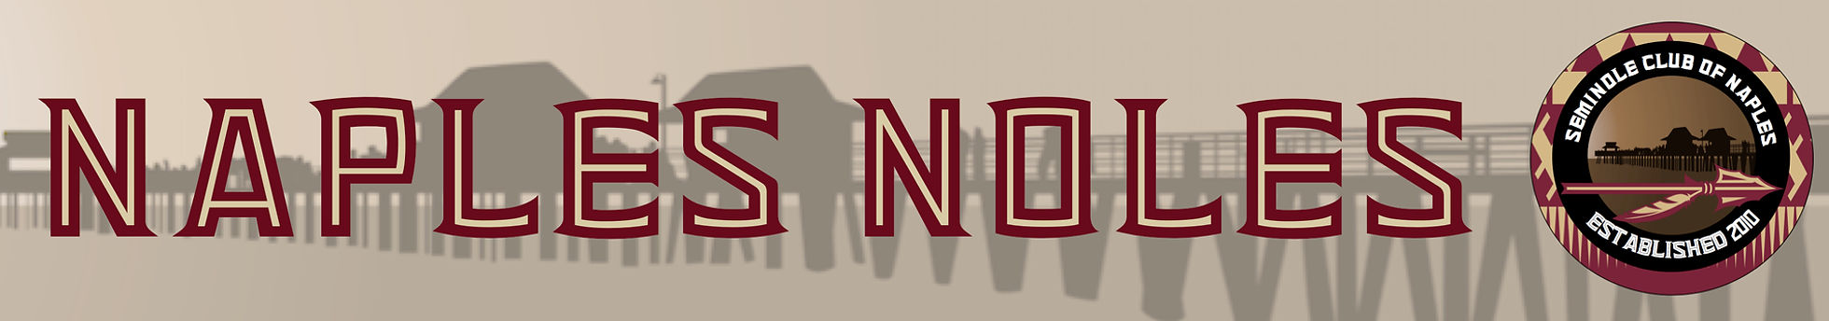
SPONSORSHIP PACKAGES
SEMINOLE CLUB OF NAPLES GOLF TOURNAMENT-MAY 13, 2022

GOLD SPONSOR-$5,000
- Round of golf for 4 players at Quail Creek Country Club including reception and awards after golf
- Football signed by Coach Mike Norvel
- Company or personal name on the Leader Board plus hole sponsorship (2 signs)
- 3 seats on the helicopter that will drop the golf balls for the ball drop. 3 people who are not playing golf will be invited to ride with the pilot during the ball drop.

RENEGADE SPONSOR-$1,000
- Round of Golf for 4 players Quail Creek Creek County Club including reception and awards after golf
- Football signed by Coach Mike Norvel
- Company or personal name on the Leader Board plus hole sponsorship (2 signs)

Specialty SPONSOR-$1,500
- Round of Golf for 4 players Quail Creek Creek County Club including reception and awards after golf
- Football signed by Coach Mike Norvel
- Company or personal name on the Leader Board plus hole sponsorship (2 signs)
- Sponsor of Long Drive, Closest to Pin, or Hole in One (Choose 1)

